Practice Problems Section 8 Solutions

1. Find the magnitude and direction of the currents through each of the three resistors in the diagram.

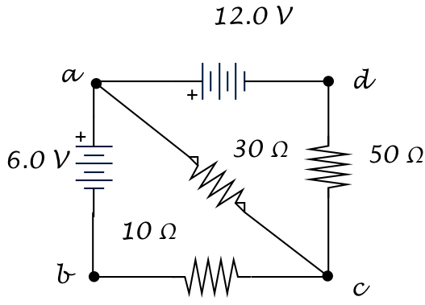

$$I_{1}$$

$$I_{2}$$

$$I_{3}$$

First, we must choose arbitrary directions for the three currents. I have chosen the directions as shown.

None of the three resistors are in series or parallel, so we will have to use Kirchhoff’s Rules directly.

We start with the junction rule. There are junctions at $a$ and $c$, and either one will work (they are redundant though, so you only need one). For instance, at junction $a$, we have $I_{1}$ and $I_{2}$ going in and $I_{3}$ going out. Thus,

$$I_{3}=I_{1}+I_{2}$$

Now we must use the loop rule. We have three unknowns and so far one equation, which means we must use two loops. (*Note that there are three possible loops in the diagram. You only need to use two of them, the third is redundant*).

I will first choose the loop from $a→c→b→a$. This yields

$$-30I_{3}-10I_{1}+6=0$$

I will then choose the loop from $a→c→d→a$. This yields

$$-30I_{3}-50I_{2}+12=0$$

I now have three equations and three unknowns (two loops and one junction). Utilizing algebra, we get

$$I_{1}=\frac{6}{115} \text{A}, I_{2}=\frac{15}{115} \text{A}, I_{3}=\frac{21}{115} \text{A}$$

Note that all the currents came out positive, which means that I chose the correct directions for them initially. Thus, the final answers are:

$I_{1}=\frac{6}{115}=.052 \text{A} \text{to the left}$ $I_{2}=\frac{15}{115}=.13 \text{A} \text{up}$ $I_{3}=\frac{21}{115}=.18 \text{A} \text{down and to the right}$

$V=IR$ $P=VI$ $\sum{I_{in}}=\sum{I_{out}}$ $\sum{V_{loop}}=0$

Resistors in Series: $R_{eq}=R_{1}+R_{2}+R_{3}+⋯$ Resistors in Parallel: $\frac{1}{R_{eq}}=\frac{1}{R_{1}}+\frac{1}{R_{2}}+\frac{1}{R_{3}}+⋯$

1. 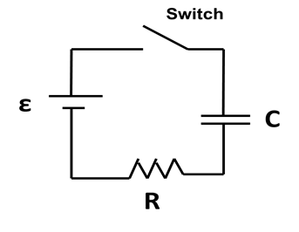In the circuit to the right, the switch is closed at $t=0$ s, and the capacitor is initially uncharged. $R$ = 500 kΩ, C = 10.0 µF and $ε$ = 12 V.
2. At what time (from $t=0$ to $t=∞$) is the charge on the capacitor a maximum? **Give a brief physical explanation why.**

The charge on the capacitor is zero at the beginning. As time moves forward, the capacitor will increase its charge due to the push of the battery. **Finally, as $t→∞$, and the system comes to equilibrium, the charge will be a maximum.**

1. At what time (from t = 0 to t = ∞) is the current in the circuit a maximum? **Give a brief physical explanation why.**

Initially, the capacitor has no charge. Therefore, it has no voltage across it, and does not affect the circuit. As the charge builds up, its voltage increases and it produces an electric field in opposition to that of the battery. Thus, the current begins to decrease. **Therefore, the maximum current occurs at $t=0$, when the capacitor has no voltage across it.**

1. Below, sketch a graph of the **current in the circuit vs. time** [ $i(t)$ vs. $t$]. Be sure to mark the following on your graph:
2. On the current axis, the numerical value of the maximum current. **Show your work in finding this!**
3. On the time axis, the numerical value of the time at which the current is $1/e=.368$ of its maximum value. **Show your work in finding this!**

The graph will be an exponentially decaying function, starting at $I_{max}$ initially and ending at $i=0$ at $t→∞$. The graph is shown in the next page.

* The maximum current occurs at $t=0$, when the capacitor plays no part in the system. Thus,
$$I_{max}=\frac{ε}{R}=2.40×{10}^{-5}\text{ A}$$

* The current is $\frac{1}{e}$ of its maximum value after one time constant $τ$. We can find the time constant by using the current function:

$$i\left(τ\right)=I_{max}e^{-\frac{τ}{RC}}=\frac{I_{max}}{e}→τ=RC=5.00 \text{s}$$

$v_{cap}(t)={q_{cap}\left(t\right)}/C$ $v_{res}\left(t\right)=i_{res}\left(t\right)R$ $i\left(t\right)={dq}/{dt}$

Charging Capacitor: $q_{cap}\left(t\right)=Q_{max}\left(1-e^{{-t}/{RC}}\right)$ $i_{circuit}\left(t\right)=I_{max}e^{{-t}/{RC}}$

Discharging Capacitor: $q_{cap}\left(t\right)=Q_{max}e^{{-t}/{RC}}$ $i_{circuit}\left(t\right)=I_{max}e^{{-t}/{RC}}$

